**USDA National Nutrient Analysis**

**By:** Kriti Srivastava

**Executive Summary**

We all know that healthy eating is an essential part of a healthy lifestyle. The modern diet is full of processed food which generally lacks the essential nutrients. The habit of eating unhealthy food can lead to inadequate intake of necessary nutrients. Such a diet can lead to causes like diabetes, hypertension, anemia, and obesity. Therefore, it is essential to understand healthy eating , as it is absolutely essential to understand the nutrients that we consume from our daily eating products. Sometimes even if we eat healthy food, our body is deficient in some important nutrients. Therefore, this study is to analyze different food products with their nutrients in it and trying to answer following questions:

* How to gain and retain maximum energy?
* Is it possible to explain the food products based on classification of their nutrients description?
* If yes, is there any relationship between the nutrients ?

**Database Content**

This study is made on the USDA (U.S. Department of Agriculture) National Nutrient database back. The USDA National Nutrient Database for Standard Reference (SR) is the major source of food composition data in the United States. It provides the foundation for most food composition databases in the public and private sectors. This version, Release 27 (SR27), contains data on 8,618 food items and up to 45 food components.The sample dataset is a flattened version of the USDA National Nutrient Database, from the now outdated version SR27.

**Methods:**

* The Principal component analysis of the nutrients of the food sample was implemented to explain the food products based on classification of their nutrients description.
* Canonical correlation analysis was implemented on the components of PCA analysis to find the correlation between the PCA components to study the correlation between different food groups explained by its nutrients.

**Results:**

* In PCA analysis, the food nutrients can be reduced to three major components as fiber-riched carbohydrates, anti- anemic nutrients that is very rich in vitamins, iron and zinc and finally high protein nutrients.
* In food items as Fiber- rich Carbohydrates increases, Anti-anemic food nutrients also increase. Similarly, as Fiber- rich Carbohydrates increase in the food items, high protein nutrients are also observed to be increased.

**Future Works:**

* This study is done on the outdated version SD27 of USDA National Nutrient Database which has only 35 nutrient variables however, the latest version has upto150 nutrient components.
* This study only shows how the food products are rich or deficits in different good components however, it does not cluster the food products or labels the good product into categories on the basis of their nutrient factors.
* This study does not include the relationship between the components produced from the factor analysis which can be done in the future analysis.

**Limitations:**

* The study does not identify the amount / portion of the nutrients are needed in our diet.
* Absence of data to study the estimation of the risk of disease with nutrient patterns.

**Conclusions:**

It was found that Fiber - rich Carbohydrates that are a rich source of fiber, as fiber itself is a form of carbohydrate. Anti-anemic nutrient : includes high content of iron with vitamin C and zinc anti-anemic diet is good for people struggling with anemia. High-Protein includes proteins and good fats that are good for building muscles and are very important especially for athletes.

It was also observed that the nutrients patterns are related to each other as : In food items as Fiber- rich Carbohydrates increases, Anti-anemic food nutrients also increase. Similarly, as Fiber- rich Carbohydrates increase in the food items, high protein nutrients are also observed to be increased.

**Technical Summary**

**Abstract:**

Nutrition is the preeminent part of everyone's life starting from the new born baby to oldsters. Every person in the age group of 20-40 is aiming to gain and retain a healthy lifestyle. Gym can help shape the physique of people but nutrition also plays a vital role to achieve the goal. In this paper we are introducing the various approaches performed on USDA dataset containing the food and nutrition information. Performed PCA to find possible to explain the food products based on classification of their nutrients description. PCA, that is a dimensionality reduction approach shows the food products can be explained in a high level by three nutrient sets as protein rich food, food beneficial for anemic people and fiber rich carbs. Canonical correlation provides evidence of a strong relationship between the nutrient patterns produced from PCA.

**Introduction:**

We all know that healthy eating is an essential part of a healthy lifestyle. The modern diet is full of processed food which generally lacks the essential nutrients. The habit of eating such food can lead to adequate intake as well as lead to health problems like diabetes, hypertension, anemia, and obesity. Therefore, it is essential to understand healthy eating, it is absolutely essential to understand the nutrients we consume from our daily eating products. Sometimes even if we eat healthy food, our body is deficient in some important nutrients. Therefore, this study is to analyze different food products with their nutrients in it.

The USDA National Nutrient Database for Standard Reference (SR) is the major source of food composition data in the United States and provides the foundation for most food

composition databases in the public and private sectors. To develop and update this database, the National Food and Nutrient Analysis Program (NFNAP) was initiated in 1997 which was an InteragencyAgreement between the National Institutes of Health and the US Department ofAgriculture (USDA since then it had become the most important means of accomplishing a comprehensive update to the National Nutrient Databank. This program’s objectives were:*(1) evaluation of existing data; (2) identification of Key Foods and nutrients for analysis; (3) development of nationally based sampling plans; (4) analysis of samples; and (5) compilation and calculation of representative food composition data*. The sampling plan that was developed was based on a self-weighting stratified design where first, the U.S. was divided into four regions, then each region was further divided into three implicit strata from which generalized Consolidated Metropolitan Statistical Areas (gCMSAs) were selected. Then the Rural and urban locations were selected within gCMSAs. Commercial supermarket lists were used to select 24 outlets for food pickups; specific brands were selected based on current market share data (pounds cons ethnic and regional foods. Sampling plans have been developed for margarine, folate-fortified foods (e.g. flours, bread, and pasta), and a number of highly consumed mixed dishes . (Pehrsson, P. R., Haytowitz, D. B., Holden, J. M., Perry, C. R., & Beckler, D. G. , 2000). With the help of NFNAP and the new database system that was developed at NDL, USDA continues updating its food composition databases to support nutrition-related research in the scientific community and provides accurate and representative mean estimates of nutrient profiles in generically described foods as well as brand-specific products.

Another study (Stricker, Onland-Moret, Boer, Schouw, Verschuren, May, Beulen , 2013) was aimed to explore differences between dietary patterns derived from principal component analysis (PCA) and k-means cluster analysis (KCA) in relation to their food group composition and ability to predict CHD(Chronic Heart Disease) and stroke risk. Both PCA and KCA extracted a prudent pattern (high intakes of fish, high-fiber products, raw vegetables, wine) and a western pattern (high consumption of French fries, fast food, low-fiber products, other alcoholic drinks, soft drinks with sugar) with small variation between components and clusters. PCA and KCA found similar underlying patterns with comparable associations with Chronic Heart Disease and stroke risk. A prudent pattern reduced the risk of Chronic Heart Disease and stroke.

There was similar study (McCann, S., Marshall, J., Brasure, J., Graham, S., & Freudenheim, J., 2001) *“to assess the effect of different methods of classifying food use on principal components analysis (PCA)-derived dietary patterns, and the subsequent impact on estimation of cancer risk associated with the different patterns.”*

The source of data for our study is a flattened version of the USDA National Nutrient Database. This study involves the various approaches to questions related to food and their nutrition value. With the help of regression techniques like Multiple regression and Dimensionality reduction techniques like principle component analysis and factor analysis also canonical correlation analysis gives profound results.

**Methods:**

The **principal Component Analysis (PCA)** was used to see if the food products can be explained with less nutrients.

For PCA analysis **,** the data was first cleaned up by omitting zeros as entries with zeros are considered as missing values. On performing the normality test, it was found that most of the feature distributions were skewed therefore, log transformation was applied on all the features which made the distributions of features either symmetric or moderately skewed.

The factorability was tested by performing Kaiser-Meyer-Olkin factor adequacy Test, Bartlett's Test of Sphericity, and Reliability Analysis using Cronbach's Alpha.

After performing the sensitivity test, PCA analysis was made for creating three components.

A **Canonical Correlation Analysis (CCA)** is conducted to evaluate the multivariate shared relationship between the two variable sets that were obtained from PCA. One of them is done between RC3 and RC2, which is FiberRichedCarbsFood and Anti-AnemicFood respectively. Second one is done between RC3 and RC1, which is FiberRichedCarbsFood and HighProtienFood respectively.

**Results and Discussions:**

Three tests of factorability on the entire data set was performed before performing PCA:

• Kaiser-Meyer-Olkin factor adequacy Test: Overall MSA = 0.89 (Since it was greater than .7 that suggests that sample of dataset is good for performing the PCA analysis).

• Bartlett's Test of Sphericity: p-value < 2.22e-16 which is very small that shows we had enough variance in the data so we can perform factor analysis)

• Reliability Analysis using Cronbach's Alpha: raw_alpha = 0.92 that also suggests that the sample data is good to perform PCA.

PCA summary information (Fig:2) shows, approx. 80% of the cumulative variance is explained by 5 components. Approx 47% of the cumulative variance is explained by the

first component itself however 3 components are determined by the Scree plot (Fig: 3) which is greater than 1 Eigenvalue.However, On performing the Knee test, there are 2

components. Since 68% of the cumulative variance is determined by the 3 components

Therefore, the decision was taken to choose 3 components for the PCA model.

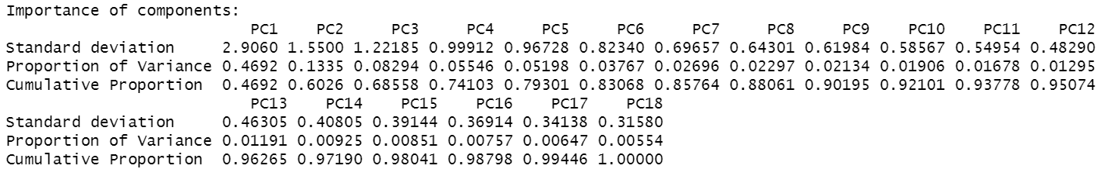  
 **Fig:2 Importance of components in PCA summary information**

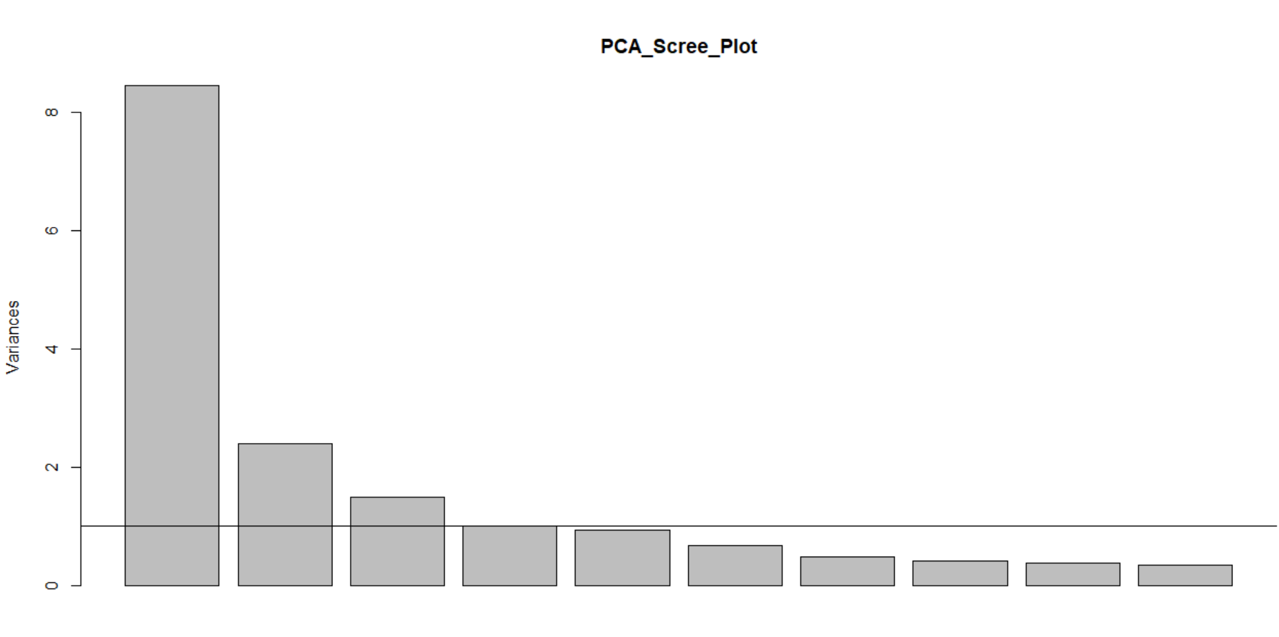  
 **Fig:3 Scree plot of PCA of USDA National Nutrient Database**

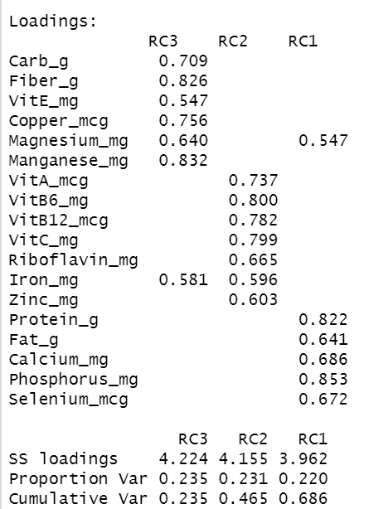

**Table4: PCA components**

Since the variables are independent, the factor rotation used in PCA analysis was “varimax”

with nfactors = 3

the components generated from the CPA analysis can be seen in the table 4:

Component RC3, formulated by Carb_g, Fiber_g , VitE_mg, Copper_mcg, Maganese_mg. Since, Magnesium_mg is explained by 64% of the variance in RC3 however only 54% by RC1 therefore, therefore, we choose to keep Magnesium_mg with RC3. Since this group of food is rich in fiber, Vitamin E as well as carbohydrates, therefore, it was better to rename RC3 as FiberRichedCarbsFood.

Component RC2, formulated by VitA_mcg, VitB6_mg, VitB12_mcg, VitC_mg, Riboflavin_mg, Zinc_mg. Since, Iron_mg was explained by 60% of variance in RC2 however only 58% by RC3 therefore, it was better to keep Iron_mg with RC2. Since, this group of food is rich in Vitamins, iron, and zinc and the foods rich in vitamin C helps in the absorption of iron therefore, they are good for anemic people hence, component RC2 renamed as Anti-anemicFood.

Component RC1 is formulated by Protein_g, Fat_g, Calcium_mg, Phosphorus_mg, Selenium_mcg. Since this group of food is rich in protein and fats, therefore, it was better to rename component RC1 as HighProteinFoods.

**Canonical correlation Analysis between RC3(FiberRichedCarbsFood) and RC1(HighProtienFood ).**

The variables from the three components in PCA analysis have correlation among themselves and thus a canonical correlation analysis is conducted using the results or components obtained from the PCA analysis. CC analysis for the components RC3 and RC1 is conducted by considering 3 components which are most significant according to the wilks lambda test.

**Table2: Canonical Correlations between RC3(FiberRichedCarbsFood) and RC1(HighProtienFood ):**



79% of overlapping variance is explained by the first canonical variate CV1. Similarly 37% of the overlapping variance is explained by the second canonical variate CV2.

**Canonical correlation analysis between RC3(FiberRichedCarbsFood) and RC2(Anti-Anemic Food):**.

As mentioned earlier, the three components are obtained from results of PCA analysis. CCA is performed on the following two components, RC3(FiberRichedCarbsFood) and RC2(Anti-Anemic Food).

**Table3: Canonical Correlations between RC3(FiberRichedCarbsFood) and RC2(Anti-Anemic Food):**  
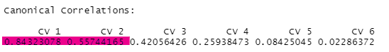

There is medium positive correlation between both the groups which is being explained in the CV1 and CV2. **Based on the CV1:** 84% of the overlapping variance is explained between the canonical variate pairs of FiberRichedCarbsFood and Anti-Anemic Food. There is 16% of the variance unexplained. **Based on the CV2:** 55% of the overlapping variance is explained between the canonical variate pairs of FiberRichedCarbsFood and Anti-Anemic Food. There is 45% of the variance unexplained.

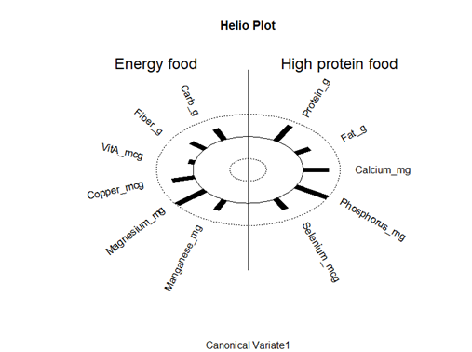

**Fig 5 : Helio Plot of FiberRichedCarbsFood and HighProteinFoods**

From the helio plot of the first variate we see that the foods with high Magnesium content are also more likely to be rich in phosphorus. Moreover, the variables in Energy food sources which are also called FiberRichedCarbsFood have positive relation among themselves in the first variate.

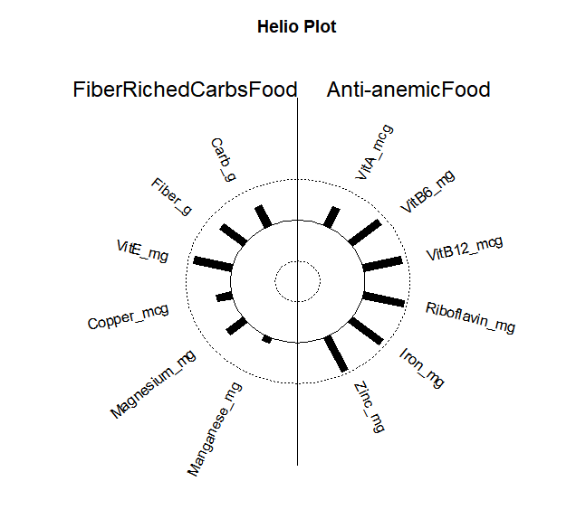

**Fig 6 : Helio Plot of FiberRichedCarbsFood and Anti-anemic Food**

This makes VitE_mg and Fiber_g as the most important and influential variables for its covariates which is the predictor variate FiberRichedCarbsFood. VitB6_mcg, VitB12_mcg,Riboflavin_mg, Iron_mg , and Zinc_mg are the most important and influential variables for its covariates which is the predictor variate Anti-Anemic Food. Also, the variables seem to have positive correlation among themselves.

Also, on looking at the table 2: we can see that 79% of overlapping variance is explained by the first canonical variate CV1

From table3: 84% of the overlapping variance is explained between the canonical variate pairs of FiberRichedCarbsFood and Anti-Anemic Food. There is 16% of the variance unexplained.

**Future Works:**

* This study is done on the outdated version SD27 of USDA National Nutrient Database which has only 35 nutrient variables however, the latest version has upto150 nutrient components.
* This study only shows how the food products are rich or deficits in different good components however, it does not cluster the food products or labels the good product into categories on the basis of their nutrient factors.
* This study does not include the relationship between the components produced from the factor analysis which can be done in the future analysis.

**Limitations:**

* The study does not identify the amount / portion of the nutrients are needed in our diet.
* Absence of data to study the estimation of the risk of disease with nutrient patterns.

**Conclusion:**

It was found that Fiber - rich Carbohydrates that are a rich source of fiber, as fiber itself is a form of carbohydrate. Anti-anemic nutrient : includes high content of iron with vitamin C and zinc anti-anemic diet is good for people struggling with anemia. High-Protein includes proteins and good fats that are good for building muscles and are very important especially for athletes.

It was also observed that the nutrients patterns are related to each other as : In food items as Fiber- rich Carbohydrates increases, Anti-anemic food nutrients also increase. Similarly, as Fiber- rich Carbohydrates increase in the food items, high protein nutrients are also observed to be increased.

**References:**

[1] Pehrsson, P. R., Haytowitz, D. B., Holden, J. M., Perry, C. R., & Beckler, D. G. (2000). USDA’s National Food and Nutrient Analysis Program: Food Sampling. *Journal of Food Composition and Analysis*, *13*(4), 379–389. <https://doi.org/10.1006/jfca.1999.0867>

[2] US Department of Agriculture, Agricultural Research Service, Nutrient Data Laboratory. USDA National Nutrient Database for Standard Reference, Release 28 (Slightly revised). Version Current: May 2016. Internet: <http://www.ars.usda.gov/ba/bhnrc/ndl>

[3] McCann, S., Marshall, J., Brasure, J., Graham, S., & Freudenheim, J. (2001). Analysis of patterns of food intake in nutritional epidemiology: Food classification in principal components analysis and the subsequent impact on estimates for endometrial cancer. Public Health Nutrition, 4(5), 989-997. doi:10.1079/PHN2001168

[4] Stricker, M., Onland-Moret, N., Boer, J., Schouw, Y. V., Verschuren, W., May, A., . . . Beulens, J. (2013). Dietary patterns derived from principal component- and k-means cluster analysis: Long-term association with coronary heart disease and stroke. *Nutrition, Metabolism and Cardiovascular Diseases,* *23*(3), 250-256. doi:10.1016/j.numecd.2012.02.006

[5] Uusitalo, L., Nevalainen, J., Salminen, I., Ovaskainen, M., Kronberg-Kippilä, C., Ahonen, S., . . . Virtanen, S. M. (2011). Fatty acids in serum and diet - a canonical correlation analysis among toddlers. *Maternal & Child Nutrition,* *9*(3), 381-395. doi:10.1111/j.1740-8709.2011.00374.x  
<https://onlinelibrary.wiley.com/doi/epdf/10.1111/j.1740-8709.2011.00374.x>

#### 